**EXPERIMENT-18**

**DATE;03-10-2025**

**AIM;** Demonstrate Infrastructure as a Service (IaaS) by creating a resources group using a Public Cloud Service Provider (Azure), configure with minimum CPU, RAM, and Storage.

**PROCEDURE;**

**STEP1:** CREATE AN ACCOUNT IN MICROSOFT AZURE.

**STEP2:** GOTO RESOURCE GROUP AND CREATE A RESOURCE GROUP.

**STEP3:** GIVE NECESSARY THINGS FOR RESOURCE GROUP.

**STEP4:** CREATE A VIRTUAL NETWORK FOR TO CREATE A VIRTUAL MACHINE.

**STEP5**: NOW CREATE A VIRTUAL MACHINE WITH UR IP ADDRESS AN USERNAME AND PASSWORD FOR YOUR VIRTUAL MACINE.

**STEP6**: AND YOUR VIRTUAL MACHINE IS DEPLOYED.

**STEP7:** NOW CONNECT THE VIRTUAL MACHINE AND DOWNLOAD THE RDP FILE TO OPEN YOUR WINDOWS VIRTUAL MACHINE.

**STEP8:** NOW RESIZE THE VIRTUAL MACHINE SIZE.

**STEP9:** CREATED A NEW WINDOWS VIRTUAL MACHINE

**IMPLEMENTATION:**

**OUTPUT;**

**STEP1: CREATE AN ACCOUNT IN MICROSOFT AZURE.**

**STEP2: GO TO RESOURCE GROUP AND CREATE A RESOURCE GROUP.**

**STEP3: GIVE NECESSARY THINGS FOR RESOURCE GROUP.**

**STEP4: CREATE A VIRTUAL NETWORK FOR TO CREATE A VIRTUAL MACHINE.**

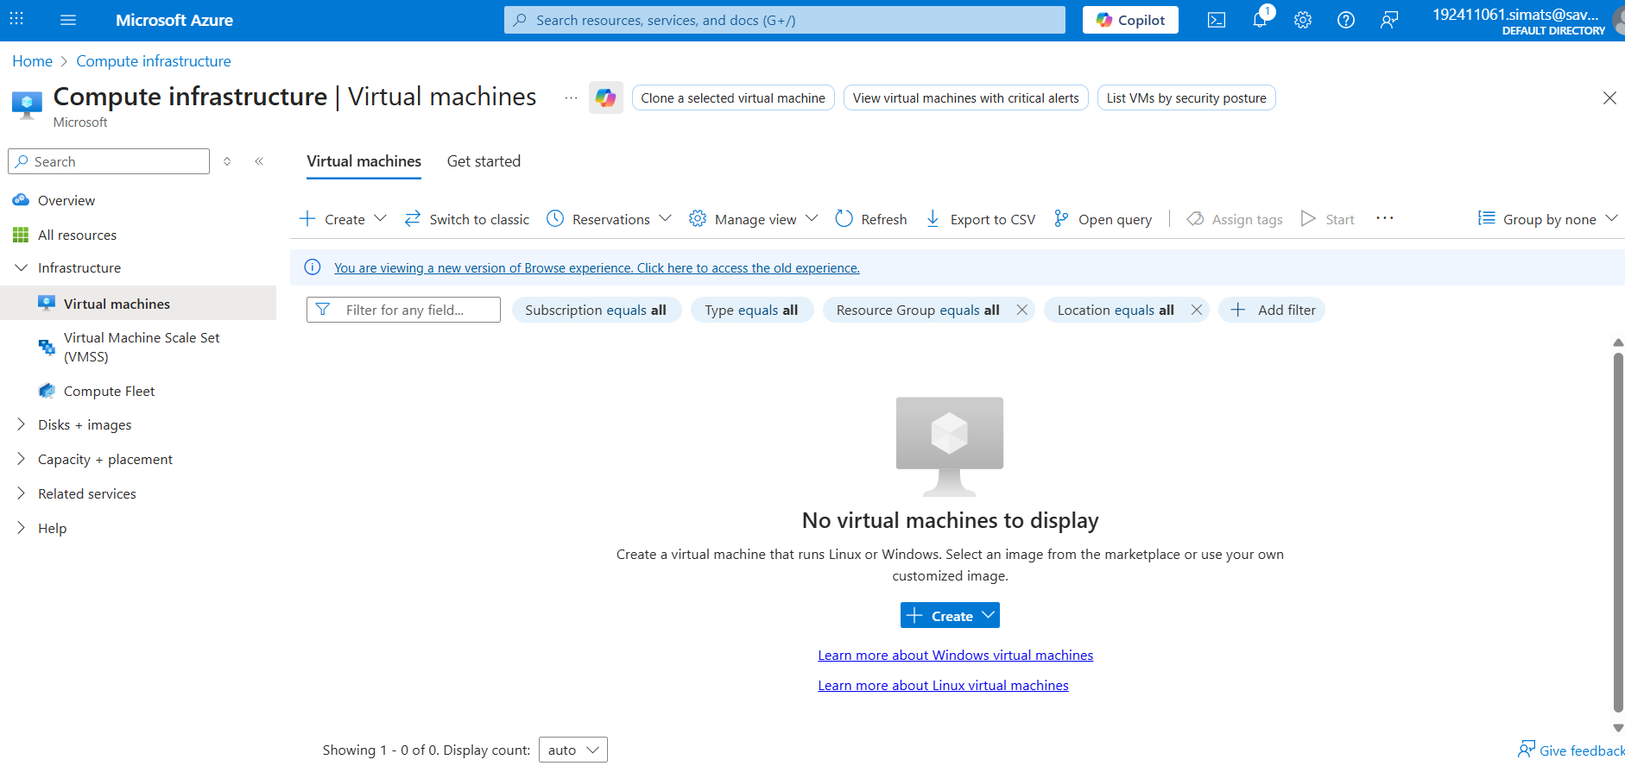

**STEP5: NOW CREATE A VIRTUAL MACHINE WITH UR IP ADDRESS AN USERNAME AND PASSWORD FOR YOUR VIRTUAL MACINE.**

**STEP6: AND YOUR VIRTUAL MACHINE IS DEPLOYED.**

**STEP7: NOW CONNECT THE VIRTUAL MACHINE AND DOWNLOAD THE RDP FILE TO OPEN YOUR WINDOWS VIRTUAL MACHINE.**

**STEP8: CREATED A NEW WINDOWS VIRTUAL MACHINE.**

**RESULTS;** successfully Demonstrated Infrastructure as a Service (IaaS) by creating a resources group using a Public Cloud Service Provider (Azure), configure with minimum CPU, RAM, and Storage.